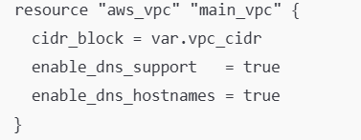
Creates the VPC using var.vpc_cidr (example 10.30.0.0/16).
Enables DNS features so instances can resolve DNS and get hostnames.

Attaches an internet gateway to the VPC.
Needed so public subnets can reach the internet.

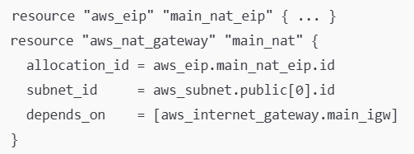
NAT gateway sits in a public subnet.
Private subnets route “0.0.0.0/0” to NAT so private instances can download updates, etc., without being publicly reachable.
One NAT was created in public [0] (one AZ). That’s okay for a lab, but for production you’d usually do one NAT per AZ for resilience.

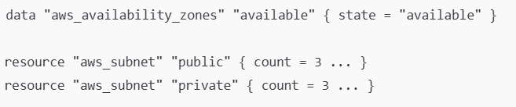
Public subnets
three public subnets, each in a different AZ.
Map public ip on launch = true → EC2 launched here automatically gets a public IP.
Private subnets
three private subnets, each in a different AZ.
Map public ip on launch = false → no public IPs.
CIDR math
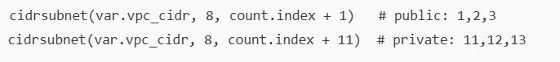
If var.vpc_cidr is /16, adding 8 makes /24 subnets
So you get something like:
Public: 10.30.1.0/24, 10.30.2.0/24, 10.30.3.0/24
Private: 10.30.11.0/24, 10.30.12.0/24, 10.30.13.0/24

Public Route Table
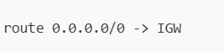
Public subnets can go out to the internet directly

Private Route Table
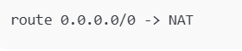
Private subnets can go out to the internet through NAT

Transit Gateway
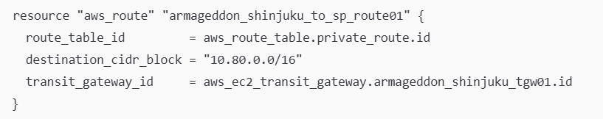
Adds a route so anything in private subnets can reach 10.80.0.0/16 by going through the Transit Gateway.

Security Groups EC2-lab-sg
Inbound:
HTTP 80 from anywhere
SSH 22 from one specific IP (My IP)
Outbound:
all traffic allowed
RDS security group
Allows MySQL 3306 from:
the EC2 lab SG (“only EC2s in this SG can connect”)
São Paulo CIDR 10.80.0.0/16 (so São Paulo can reach the DB)

RDS subnet group + RDS instance

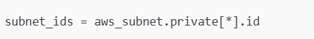
Tells RDS to live inside your private subnets (best practice).
DB instance
- Creates a MySQL (or whatever var.db_engine is) DB
- Not publicly accessible
- Uses the RDS SG you defined

EC2 instance (public)
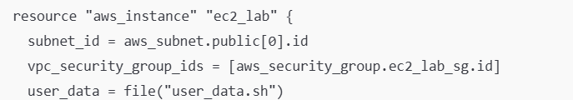
Launches an EC2 in the first public subnet (so it has internet + public IP)
Attaches an IAM instance profile so the EC2 can call AWS APIs (SSM, CloudWatch logs, Secrets Manager, etc.)
Runs the user_data.sh bootstrap script at launch.

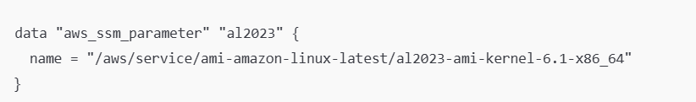
Uses Amazon Linux 2023 AMI pulled dynamically from SSM

IAM role + instance profile (permissions for EC2)
An IAM role EC2 can assume (assume role policy for ec2.amazonaws.com)
Several custom policies attached to that role:
- Read a specific secret: secretsmanager:GetSecretValue for lab/rds/mysql*
- CloudWatch agent-ish permissions (logs APIs + SSM parameter reads for AmazonCloudWatch-*)
- SSM Managed Instance Core-like permissions (so SSM Session Manager works)
- Read only these SSM parameters you create (endpoint/port/name)

EC2 uses the instance profile to get those permissions

Secrets Manager (store DB connection info)
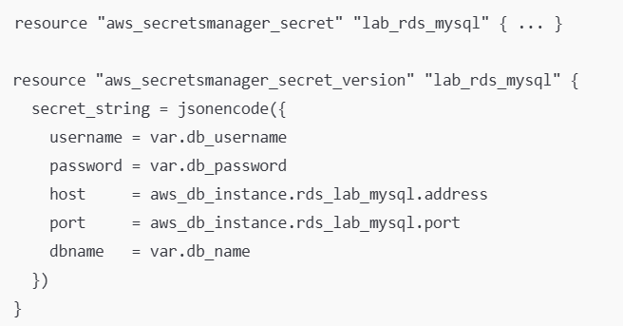
Creates a secret called lab/rds/mysql
Stores a JSON payload containing username/password/host/port/dbname.
The EC2 role can read this (because a policy is attached for it)

SSM Parameter Store
Creates 3 parameters:
- lab-db-endpoint
- lab-db-port
- lab-db-name
And you attached IAM permission so EC2 can read those exact parameters
CloudWatch logging + metric filter + alarm + SNS email
Log group
Creates a log group rds-app with 7-day retention
Metric filter
If logs contain the string "OperationalError", it increments a custom metric DBConnectionErrors.
Alarm
If DBConnectionErrors >= 3 in 1 minute → triggers alarm action
SNS
SNS topic db-incidents
Email subscription to var.sns_email_endpoint so you get alerted.

